DC WEBSITE SECTIONS
- Header
- Media Logo Strip
- Cognition and Motor Function Improvements
- Mental and Emotional Health Benefits via Clinical Trial
- Datapoints from Bloodwork via Clinical Trial
- Testimonials
- CTA – Be Part of a Modern Miracle
- Science Statistics Strip
- Importance of Consciousness
- Evolve Your Consciousness
- Path to Enlightenment
- Only Enlightened Beings can Bless and Transform
- Summary of Science Research – Life Sciences and Materials Science
- Miracles are Here – side by side photo slideshow
- Trusted Pioneers – Guruji, Dahryn and Alice
- Guruji’s Extraordinary Physiology
- Vision & Mission
- Science Behind Blessings
- Blog
- CTA – Interested in Becoming a Community Member
- Contact US
- Footer

Navigation Menu Items

About
Benefits
Science
Resources
Memberships

1.
HEADER
Headline

Higher Consciousness: The Ultimate Solution to Optimize Your Potential
Experience Success, Health, Wealth and Happiness

Credibility Qualifiers
Scientifically Validated
Clinically Proven
Unprecedented Breakthrough

CTA:
Our Memberships

2.
Media Logos Strip


3.
Cognition and Motor Function Improvements

Unlock Your Mind, Reclaim Clarity, Strength & Vitality

Dramatically improve memory, focus, attention, thinking, expression of feelings, mobility, endurance, balance, and strength.

Clinically Proven via NIH Toolbox Trials,
Powered by Higher Consciousness
Life-changing.

4.
Mental and Emotional Health Benefits via Clinical Trial

A Clinically Proven Breakthrough for a Better Quality of Life

More than one billion people worldwide suffer from psychological, emotional and mental health problems. Modern healthcare often treats the symptoms and offers a limited scope of relief with many long-term side-effects. Alternative and complementary medicine and therapies take significant time and offer very little. This is because modern science does not take into account the existence of the soul (consciousness), which is what ultimately operates the mind. The Grace of God is the only solution for people suffering from mental and psychological problems.

The unprecedented results of the clinical trial offer a remarkable path in the promotion of overall health and wellness as well as a profound sense of well-being and personal development that extends into every corner of life, manifesting as improved sleep quality, increased energy, and heightened emotional and psychological wellness, leading to huge relief in anxiety, depression, stress, mental restlessness, sadness, fatigue, menstrual problems, emotional trauma, fast-aging and more.

These benefits include not only a deeper sense of fulfillment and purpose, but also improved decision making, higher confidence, motivation, inspiration, enthusiasm and ambition, as well as tangible improvements in prosperity, professional achievements and deeper relationships, ultimately leading to overall happiness and a better quality of life.

Over 300,000 people worldwide have experienced the incredible transformative power of Guruji Trivedi’s Blessings.

5.
True Health and Well-being through Higher Consciousness
100+ Parameters Measured in Blood Analysis via Clinical Trial

Inflammation
- IL-6 (Interleukin-6): ↓ 76%
- IL-1β (Interleukin-1 beta): ↓ 94%
- IL-8: ↓ 72%
- TNF-α: ↓ 95%
Reduction in the above inflammatory markers suggest that your body becomes a less reactive, more peaceful environment for healing, reducing stress and inflammation, bringing calmness and clarity.

Immunity
- CD8+CD28− Cell Count: ↑ 25%
Boosts immunity, the natural defense against illness.

Nutrition
- Vitamin B12: ↑ 15%
- Vitamin C: ↑ 169 %
- 25-OH Vitamin D3: ↑ 42%
Sharper focus, enhanced mood and nerve health, stronger immunity, higher energy, and overall vitality, improved bone health - all naturally.

Cardiovascular
- Oxidized LDL: ↓ 30%
Reducing cardiovascular risk and promotes healthy aging.

Hormones
- Insulin: ↑ 88%
Supports better energy, metabolism, and balanced blood sugar.

Anti-Aging
- Klotho Protein: ↑ 685%
A game-changer for slow aging.

6.
Testimonials
AS IS

Slider



7.
CTA

Be a Part of a Modern Miracle

8.
Science Statistics Strip

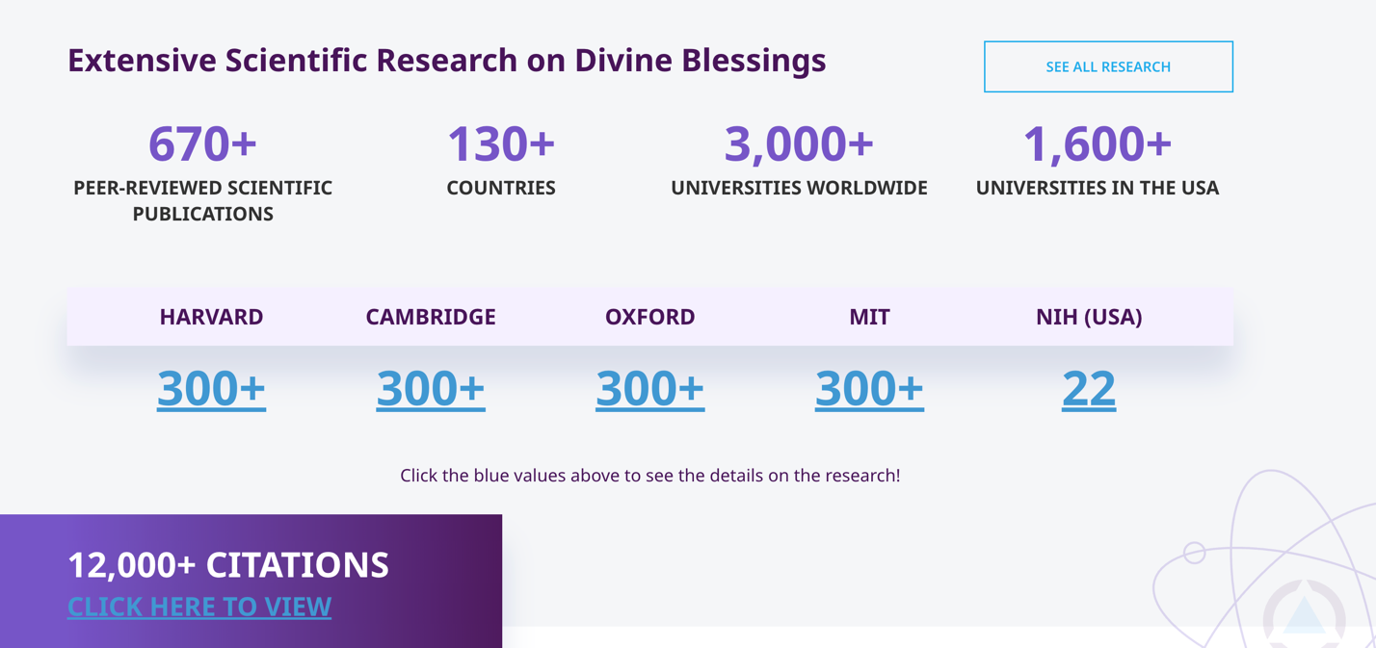
9.
Importance of Consciousness (134)

The natural characteristics of Consciousness are to organize and evolve everything, non-living as well as living, for higher purpose and a better quality of life.

Science, Religion and Spirituality are trying to understand God, Consciousness and God’s creation in the form of the universe from different angles. Where Science is the discovery of consciousness, Religion is the adoption of consciousness and spirituality is the implementation of consciousness.

“Consciousness is fundamental and Matter is the derivative of consciousness”
Max Planck, Nobel Laureate

As per religion: God created the universe by His word, out of nothing, without any prior materials - to reveal His Glory.

As per spirituality, consciousness is the mind of God, which is responsible for the existence and systematic functioning of the universe along with everything else in the universe.
10.

Evolve Your Consciousness (243)
To Discover Your Purpose in Life, Ultimate Freedom, Well-being, Prosperity and Happiness

Our five senses are continuously collecting data from our environment. A very small percentage of these sensory inputs reach the brain, where they are translated, interpreted and finally converted into reality by the brain. The brain reconstructs an approximation which might be far away from reality.

For example, our eyes transmit millions of bits of data per second, yet the brain at its best receives less than a 150 bits of data per second. The brain compensates by filling in missing information using memory, prior experience, depth, color, etc. and as a result what we experience is not a direct reflection of objective reality, but an approximation. This scenario is not limited just to the eyes, but is similar across all sensors including smelling, hearing, tasting and touching.

As a result, the final perception of reality formed through the brain is different across people. Very small number of people form a correct perception of reality, while most people either form an incorrect or a partially correct perception.

These differing forms of perception of reality across people are governed by their level of Consciousness.

Without evolution of Consciousness, people are living with partially correct or incorrect perception of reality, which leads to delusion, confusion, frustration and finally a miserable life.

For a better quality of life, the evolution of Consciousness is mandatory to experience the correct perception of reality.

11.
Path to Enlightenment

Neuroscience says when the brain is orderly, our thoughts are orderly and finally our actions are orderly, which is only possible through higher consciousness.

A human being is the totality of mind, body and spirit. Persistent, unnecessary and uncontrolled thoughts contribute to a disordered state of mind, ultimately shaping our reality. However, the challenge lies in our inability to effectively control and regulate the mind's state. Our consciousness, in the form of our spirit, holds the reins over our minds, possessing the ability to command both the mind and its ongoing thoughts. Through its organizing, evolving and elevating influence, consciousness leads us to attain complete freedom - often referred to as salvation or Enlightenment. This liberation marks the end of mental slavery, ushering us into a tranquil existence where we wield absolute control over our thoughts. This newfound control shields us from the uncertainties of life, alleviating constant anxiety and reducing stress levels. Useless and unwanted thoughts no longer dictate our experience of life, and instead we become masters of our own realities.

Start Your Path to Enlightenment

12.
Only Enlightened Beings Can Bless and Transform

The basic character of consciousness is to organize and evolve for optimal potential and finally become free. Every human and object that exists within nature is controlled and regulated by the consciousness of nature. At the height of this freedom is Enlightened consciousness. Enlightened beings have a consciousness higher than the consciousness of nature because they are deeply connected to the Creator (God), hence, they have the ability to Bless and transform anything.

This is why religious leaders and spiritual masters have never attempted to bless or transform any non-living material or any living organism other than humans. This is because without Enlightened consciousness, their blessing or healing will show no impact when measured and validated in a science laboratory through sophisticated technologies.

While many are familiar with Enlightenment, it is not a word to be used lightly.
It represents the power and magnitude of transforming lives at all levels through Divine Blessing. The experiments conducted by Guruji Trivedi have demonstrated that when a person becomes Enlightened, they have incredible power to Bless and Heal people, living organisms and non-living materials for their highest performance.

Nature displays the highest level of consciousness, which is why it maintains control, orchestrates operations, and regulates everything within it. This elevated consciousness enables nature to create new materials, alter genetics (DNA), and even produce new species.

In contrast, Enlightened beings possess a consciousness that surpasses even that of nature. Inherently, this means it is only logical that Enlightened beings must have the ability to create new materials, modify the genetics (DNA) of living organisms, and generate new species. Without these abilities, a person cannot be truly Enlightened.

The Enlightenment of Guruji Trivedi and two of his disciples, Dahryn Trivedi and Alice Branton has been validated through unprecedented outcomes in multiple disciplines of science, attracting people of all different faiths worldwide because the outcome is not faith-based, it is fact-based.
Join a global community captivated by more than belief – by science.

13.
Miracles in Materials Science
Video: Dr. Ram Mohan | Dr Swanson | Dr Roy
Miraculous Achievements through Higher Consciousness

- Alter the mass and size of the atom.

- Increase particle size by over 400%.

- Increase surface area by over 300%

- Increase crystallite size by over 800%.

- Change the Energy within and between atoms.

- Increased the distance between the atoms up to 3.35% and decreased by 0.56%.

- Increased the latent heat of materials by over 600%.

- Alter Isotopic Abundance by over 500%.

- Increase electron spin resonance (ESR) signal width by over 300%.

- Increase oxygen by over 20%.
Miracles in Life Sciences

Video – Dabur

Miraculous Achievements through Higher Consciousness

- Increase agriculture yields up to 500%.

- Increase immunity in plants up to 600%.

- Increase the shelf-life of cashew nuts up to 100%.

- Chicken meat production increased over 75%.

- Soil fertility improved over 75%.

- Reduce the viral load up to 80% in preclinical research.

Learn More

14.
Miracles are Here

Animated Slideshow of Images

15.
Trusted Pioneer

Guruji Trivedi is the unprecedented pioneer, who is integrating science, religion and spirituality.

Guruji’s Blessings on humans, animals, microbes (bacteria, viruses, fungi), plants and trees, along with non-living materials have been measured, documented and published in more than 670 peer-reviewed articles in science journals and available in more than 3,000 universities all over the world.

Learn More

16.
Guruji’s Miraculous Physiology

GURUJI TRIVEDI’S
Miraculous Physiology
Acclaimed doctors and scientists across the globe associate the miraculous impact of Guruji Trivedi’s Blessings with his unique physiology. Not only does Guruji’s physiology reveal extraordinary impossibilities about the capabilities of the human body, but under Guruji’s remarkable physiological parameters, no known human exists.

At 41 years of age, the sympathetic and parasympathetic parts of his brain function simultaneously, his breathing is abdominal with little or no movement of the diaphragm, his arteries show zero percent plaquing, the elasticity of his body’s cells is far superior than that of any newborn baby and full body digital X-rays show that he still has growing cartilage at 55 years of age.
17.
VISION AND MISSION

1. To integrate Science, God and Consciousness.

2. To scientifically establish the existence and importance of God (the Creator) and higher consciousness for the betterment of humanity.

3. To improve mental, emotional, and psychosomatic health.

4. To help others spiritually grow in consciousness to enjoy a better quality of life and ultimately enlightenment.

5. To bring and establish a preventative maintenance model of the healthcare system.

6. To help to produce highly bioavailable and nutritious food products.

7. Desert reclamation and prevention of desertification.

8. Invent new materials and evolve rare earths to power computing, solar and other technologies of the future.

9. To usher in an evolutionary science through the discovery of many new phenomena through the help of Divine Grace.

18.
Science, God and Consciousness
Science Behind Blessings

“Consciousness is fundamental and Matter is the derivative of consciousness.”
Max Planck, Nobel Laureate

Atom is the fundamental particle for all matter. As per Max Planck matter is the derivative of consciousness, it means, if somehow, we can change the level of consciousness, then the changes must be reflected in the structure of the atom. Changes at the atomic level must be reflected in changes of the character, behavior and usefulness of that material. God is regulating and operating everything in the universe with the help of consciousness where the character of consciousness is to organize, evolve and optimize everything in the matter. Hence by altering the level of consciousness, the character, functionality and usefulness of every object can be altered.

Today, Guruji Trivedi has connected the missing link between God, consciousness and matter. Through more than 6,000 scientific experiments leading to 670 peer-reviewed publications, Guruji Mahendra Trivedi has demonstrated that Consciousness, as the Grace of God, is not a metaphor, a philosophy, or a belief, but a measurable, transformative fact-based reality. Through prayer to God, Guruji’s Blessings optimized the functionality and usefulness of every object, situated anywhere across the globe.

Guruji created new materials and new species, from nothing, just through his prayer to God, thereby establishing the existence of fact-based God.

Read More

19.
Blog

9 Cards with images – 3 x 3 column layout

20.
Interested in becoming a community member – CTA

21.
Contact Us Form

22.
Footer

